1. SCOPE
This standard covers the dimensions and other requirements of endless V-belts for power transmission in general industrial applications.
a) This standard also covers recommendations for transmission capacities and selection procedure for the belts.
b) The V-belts conforming to this specification are recommended for operating at ambient temperature between + 60°C and - 18°C.
2. TERMINOLOGY
For the purpose of this standard, the following definitions shall apply.
a) V-Belt
A belt, the cross-section of which is shaped roughly like a trapezium. The latter is usually isosceles. On the cross-section, the trapezium is outlined by the base, sides, and top of the belt
b) The angle of V-Belt
The included angle obtained by extending the sides of the belt.
(T) Height of the trapezium outlined in a cross-section
d) Nominal Top Width of a V-Belt (W) Top width of the trapezium outlined on a cross-section
e) Pitch Width of a V-Belt (Wp) The width of the belt at its pitch zone. The width remains unchanged when the belt is bent perpendicularly to its base. This is a basic dimension of standardization for the belt and for the corresponding pulley groove, considered as a whole.
f) Pitch Length of a Belt (Lp) The length of the pitch line of a belt. This is the circumferential length of the belt at the pitch width,
g) Pulley Groove Pitch Width (WP) That width of the pulley groove which has the same dimensions as the pitch width of the belt used with the pulley.
h) Pulley Pitch Diameter (dp) The diameter of the pulley measured at the groove pitch width.
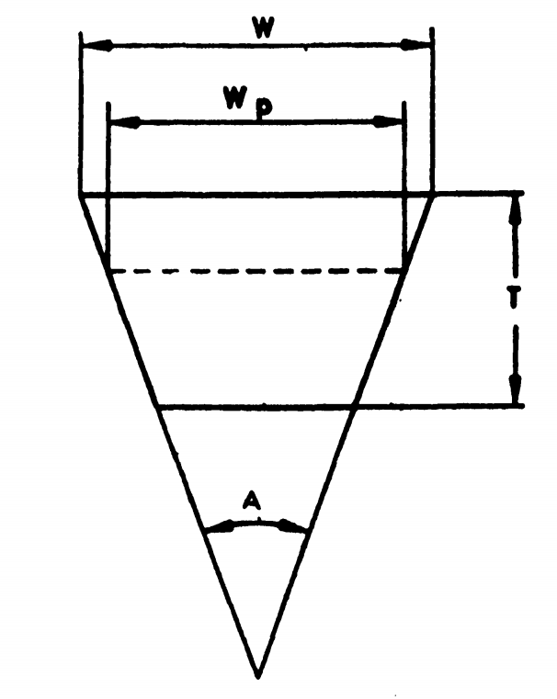
Belt cross-section dimensions

Cross Section Symbol | Pitch Width | Nominal Top Width | Nominal Height | Nominal Angle
 | Wp | W | T | A
 | (mm) | (mm) | (mm) | (degree)
Z | 8.5 | 10.0 | 6.0 | 40
A | 11.0 | 13.0 | 8.0 | 40
B | 14.0 | 17.0 | 11.0 | 40
C | 19.0 | 22.0 | 14.0 | 40
D | 27.0 | 32.0 | 19.0 | 40
E | 32.0 | 38.0 | 23.0 | 40

3. MATERIAL AND WORKMANSHIP
a) V-Belts shall consist of a suitable combination of elastomeric compound(s) with polyester cord or polyester fabric reinforcement and outside fabric of cotton or synthetic or synthetic blended fabric, coated with polychloroprene or any other suitable compound, the whole being molded together in a uniform manner and shaped in accordance with the best manufacturing practice. The V-belts should be free from any manufacturing defects like lumps, bare spots, sponginess, loose fabric joints, and any surface blemishes.
b) The reinforcing polyester cord/fabric of the V-belts shall be tested by using suitable qualitative tests. The frequency of such test shall be as agreed between the purchaser and the manufacturer.
c) The outside jacket of the V-belt shall be checked for the presence of polychloroprene rubber by using suitable qualitative tests followed where necessary by infrared spectrophotometry. The frequency of such tests shall be as agreed between the purchaser and the manufacturer.
4. CROSS SECTION DIMENSIONS
The nominal cross-section dimensions and the nominal included angle of belts shall be as given in 1. The dimensions of belts made by individual manufacturers may vary slightly from the nominal values given in Table 1, but the belts shall fit pulley grooves within

5. DESIGNATION
The V-belts conforming to this standard shall be designated by the number of this standard, the cross-section symbol, and nominal pitch length along with symbol Lp. However, belt reference No. corresponding to nominal pitch length given in Table 3B column 1 can also be incorporated.
6.BELT PITCH LENGTH AND TOLERANCES
a) Belt Pitch Length
Standard pitch lengths of V-belts of cross-section Z, A, B, C, D, and E are given in Table A and Table B. Belts with lengths other than given in Table A and Table B may be supplied if agreed to between the purchaser and the supplier. For such belts, the nominal pitch lengths shall be declared by the manufacturer.
a.1) Measurement of V-Belt Pitch Length
The V-belt is placed over two identical V-grooved pulleys, the pulley V-groove being defined and its dimensions. The pulleys shall be mounted on the parallel horizontal axis on a testbench. Apply to the sliding pulley the measuring force. Rotate the pulleys in order that the belt makes at least three revolutions ensuring proper seating of the belt in the pulley grooves and the total measuring force shall be equally divided between the two strands of the belt. Measure the maximum and minimum centre distance between the two pulleys. The pitch length is determined by the following equation:
Lp = 2E+Cp
E = (C Max + C Min)/2
where,
Lp = Pitch length of a V-belt (mm);
b = Mean centre distance (mm);
Cp = Pitch circumference of the V-belt length measuring pulley (mm)
Cmax= Maximum centre distance between the pulleys (mm)
Cmin= Minimum centre distance between the pulleys (mm).
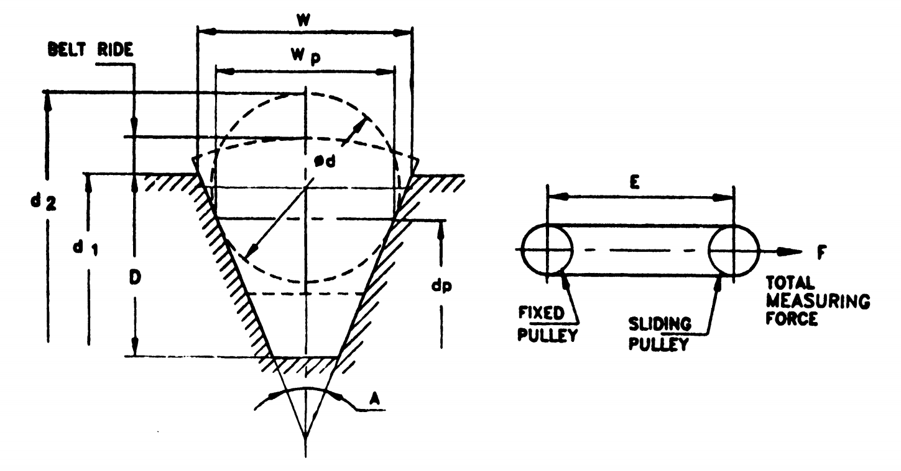
Measuring pulley dimensions Belt Pitch length measurement

MEASURING | PULLEY | DIMENSIONS |  |  |  | BELT | PITCH | LENGTH | MEASURES
Groove Cross Section Symbol | Outside Diameter | Pitch Diameter | Pulley Circum-ference at Pitch Diameter | Pitch Width of Groove | Top Width of Groove | Groove Angle | Minimum Groove Depth | Bal or Rod Diameter | Diameter Over Ball of Rods
 | di | dp | Cp | Wp | W | A | D | d | d2
 | mm | mm | mm | mm | mm | degree | mm | mm | mm
 | #0.05 | #0.05 |  |  |  | #0.15 |  | #0.013 | #0.05
1 | 2 | 3 | 4 | 5 | 6 | 7 | 8 | 9 | 10
Z | 62.30 | 57.30 | 180 | 8.5 | 10.02 | 34 | 10.0 | 9.0 | 69.308
A | 102.10 | 95.50 | 300 | 11.0 | 13.01 | 34 | 12.0 | 11.6 | 110.822
B | 135.72 | 127.32 | 400 | 14.0 | 16.56 | 34 | 15.0 | 14.7 | 146.533
C | 234.22 | 222.82 | 700 | 19.0 | 22.48 | 34 | 20.0 | 20.0 | 249.098
D | 398.18 | 381.98 | 1200 | 27.0 | 32.26 | 36 | 28.0 | 28.5 | 419.622
E | 592.16 | 572.96 | 1800 | 32.0 | 38.24 | 36 | 33.0 | 33.8 | 617.649

